**Task: Writing a Function (with parameters)**

If we had the following code:

Sub Main()

Dim x, y, result As Integer

        Console.Write("Enter value1:")

        x = CInt(Console.ReadLine)

        Console.Write("Enter value2:")

        y = CInt(Console.ReadLine)

        result = x + y

        Console.WriteLine("Result=" & result)

        Console.ReadLine()

End Sub

This is how we would write the function:

Sub Main()

Dim x, y, result As Integer

        Console.Write("Enter value1:")

        x = CInt(Console.ReadLine)

        Console.Write("Enter value2:")

        y = CInt(Console.ReadLine)

result = Add(x ,y )

Console.WriteLine("Result=" & result)

        Console.ReadLine()

End Sub

'defining a function with 2 parameters

Function Add(ByVal x As Integer, By Val y As Integer)

Dim z As Integer

Z= x + y

Return x + y

Add = x+ y

Return Z

End Function

End Module

**Exercise:**

Take your previous worked exercise (in For-loop exercise) on the program to calculate the average of 10 numbers entered by a user. **Modularise this program using a function to calculate the average.**

Module Module1

Sub Main()

Dim input(9) As Single

Dim result As Single

For Count As Integer = 0 To 9

Console.WriteLine("enter the number {0}", Count + 1)

input(Count) = Console.ReadLine()

Next

result = Avg(input)

Console.WriteLine("Average: {0}", result)

Console.ReadLine()

End Sub

Function Avg(ByVal input() As Single)

Dim sum As Single

For pCount As Integer = 0 To 9

sum += input(pCount)

Next

Return sum / 10

End Function

End Module

Output:

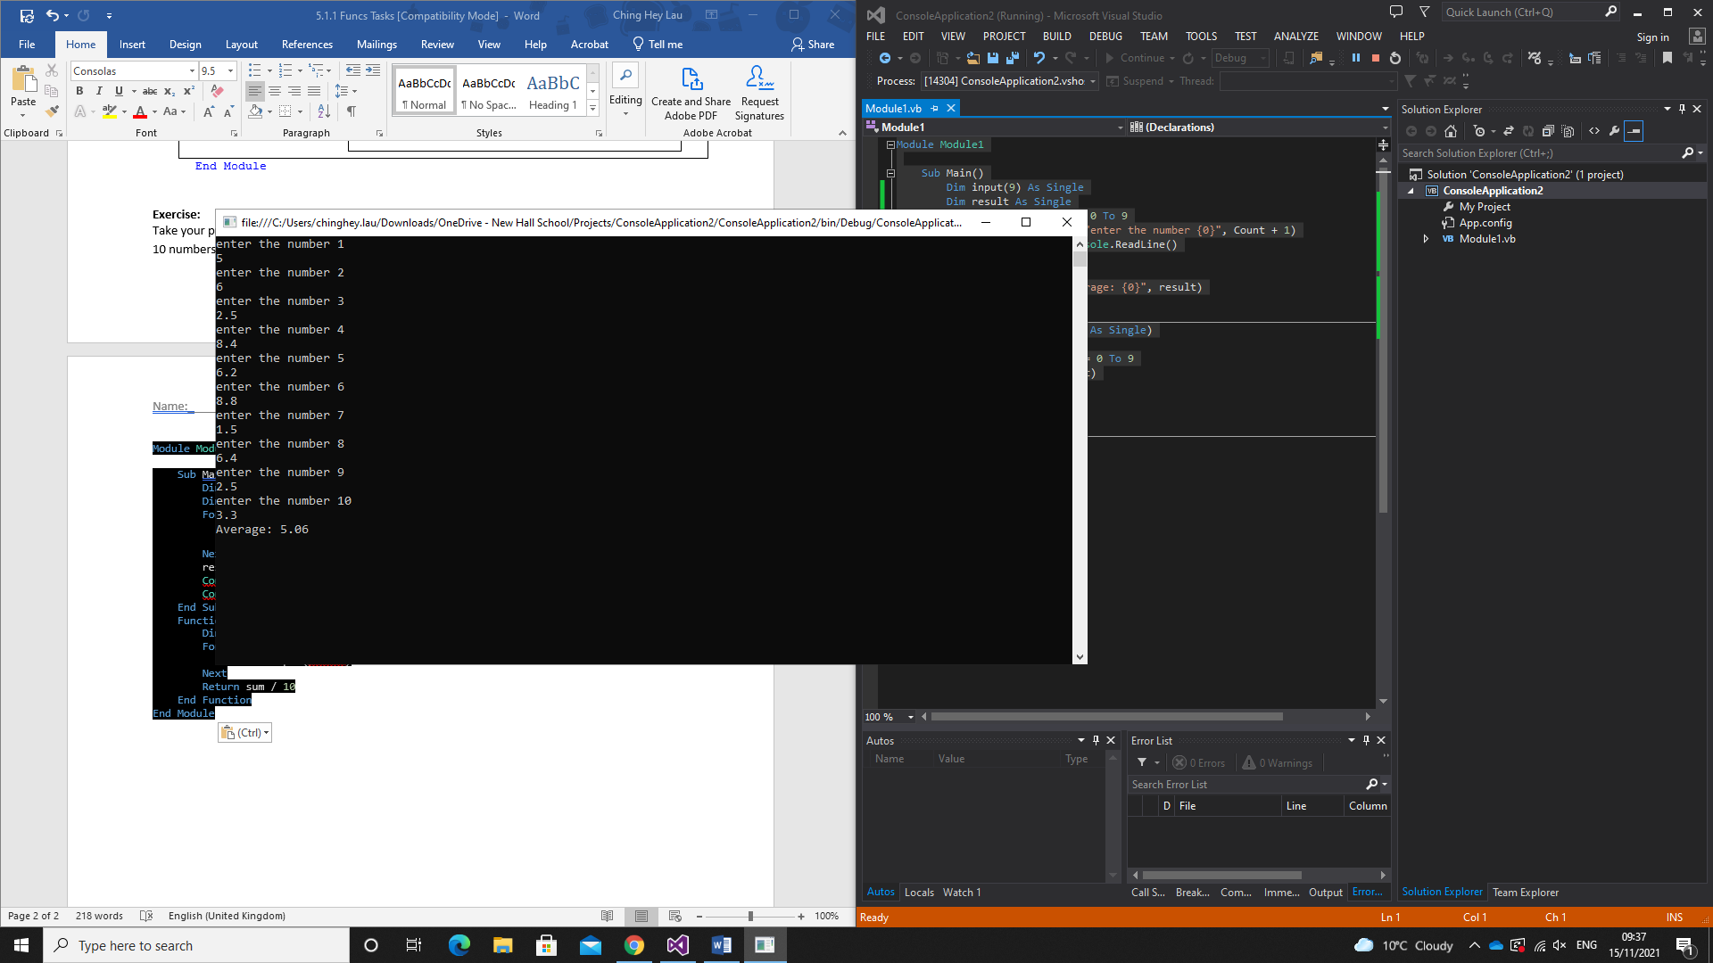

5.0.1 Proc Independent work

Module Module1

Sub Main()

Dim startnum, endnum, table As Single

Dim pupilname As String

Console.WriteLine("please enter name")

pupilname = Console.ReadLine()

Console.WriteLine("please enter the table")

table = Console.ReadLine()

Console.WriteLine("please enter start num")

startnum = Console.ReadLine()

Console.WriteLine("please enter end num")

endnum = Console.ReadLine()

Console.WriteLine()

Console.WriteLine("{0}: here is your {1}th table", pupilname, table)

For count As Integer = startnum To endnum

multiples(table, count)

Next

Console.ReadLine()

End Sub

Sub multiples(ByVal ptable As Single, ByVal pcount As Single)

Dim sum As Single = ptable * pcount

Console.WriteLine("{0} x {1} = {2}", ptable, pcount, sum)

End Sub

End Module

Independent work 5.1.1 func task

2. a By Val 15 (7+8)

B ByRef 0 (0+0)